EXPERIMENT 5

Create a Web Page for Student Registration Form with Email Validation by applying form attributes (method, action, placeholder, required).

Objectives
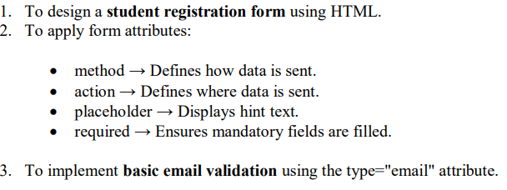
Tools Required
- Computer / Laptop with any OS
- Text Editor (VS Code, Sublime Text, Notepad++)
- Web Browser (Chrome, Edge, Firefox)

Theory
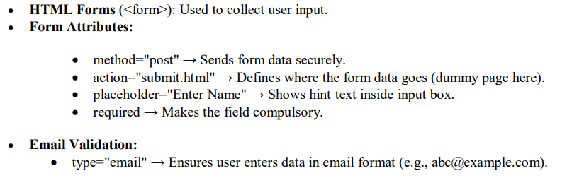

CODE IMPLEMENTATION
<!DOCTYPE html>
<html lang="en">
<head>
<meta charset="UTF-8">
<meta name="viewport" content="width=device-width, initial-scale=1.0">
<title>Student Registration Form</title>
<style>
body {
font-family: Arial, sans-serif;
background-color: #eef5ff;
margin: 0;
padding: 0;
}
h2 {
text-align: center;
color: #333;
margin-top: 20px;
}
form {
width: 400px;
margin: 30px auto;
background-color: #fff;
padding: 20px;
border-radius: 10px;
box-shadow: 0px 0px 10px rgba(0,0,0,0.1);
}
label {
font-weight: bold;
}
input, select {
width: 100%;
padding: 8px;
margin: 8px 0 16px;
border: 1px solid #ccc;
border-radius: 5px;
}
input[type="submit"], input[type="reset"] {
width: 48%;
background-color: #007bff;
color: white;
border: none;
cursor: pointer;
font-weight: bold;
}
input[type="reset"] {
background-color: #f44336;
}
input[type="submit"]:hover, input[type="reset"]:hover {
opacity: 0.9;
}
</style>
</head>
<body>

<h2>Student Registration Form</h2>

<!-- Form starts here -->
<form method="post" action="submit.html">

<label for="fullname">Full Name:</label>
<input type="text" id="fullname" name="fullname" placeholder="Enter your full name" required>

<label for="email">Email Address:</label>
<input type="email" id="email" name="email" placeholder="Enter your email address" required>

<label for="dob">Date of Birth:</label>
<input type="date" id="dob" name="dob" required>

<label for="gender">Gender:</label>
<select id="gender" name="gender" required>
<option value="">Select your gender</option>
<option>Male</option>
<option>Female</option>
<option>Other</option>
</select>

<label for="course">Course:</label>
<input type="text" id="course" name="course" placeholder="Enter your course name" required>

<label for="phone">Phone Number:</label>
<input type="tel" id="phone" name="phone" placeholder="Enter 10-digit phone number" pattern="[0-9]{10}" title="Enter a valid 10-digit number" required>

<input type="submit" value="Register">
<input type="reset" value="Clear">

</form>
<!-- Form ends here -->

</body>
</html>

Lab | Break

OUTPUT

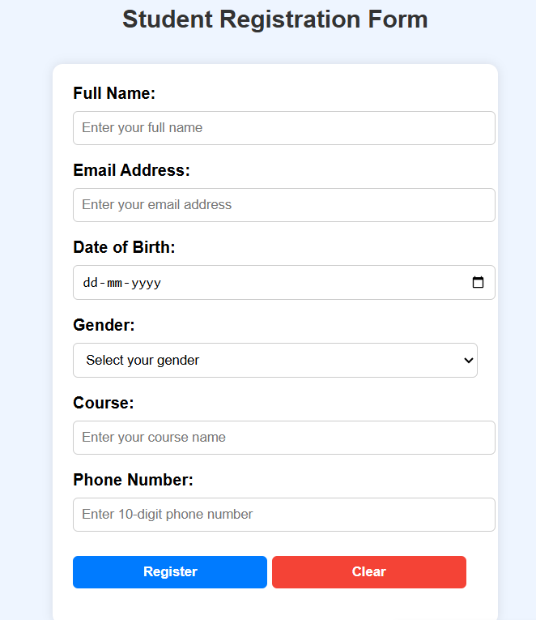

Outcome
- Successfully created a hotel room booking form webpage using HTML.
- Implemented input fields, labels, select, textarea, and buttons.
- Learned practical form design techniques for web applications.

